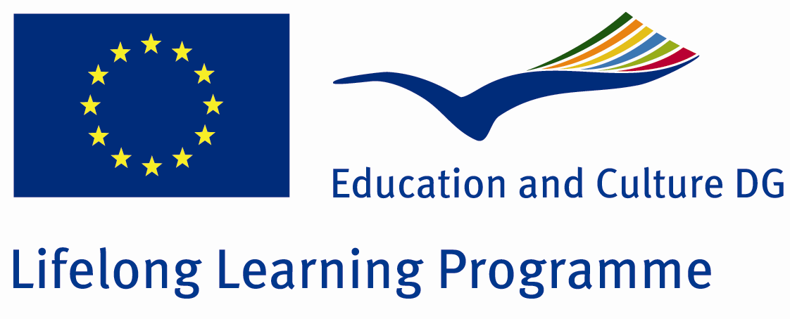

TRAINING AGREEMENT and QUALITY COMMITMENT LEONARDO DA VINCI PROGRAMME

I. DETAILS ON THE PARTICIPANT
Name of the participant: Dr. Aranka Végső
Field of vocational education: Neonatology
Sending institution (name, address): 2nd Department of Obstetrics and Gynaecology, Semmelweis University, address: 1082 Budapest, 78/A Üllői Street
Contact person (name, function, e-mail, tel): Dr. György Vereb, coordinator, e-mail: erasmus@med.unideb.hu, tel: (36) 52-258-011

II. DETAILS OF THE PROPOSED TRAINING PROGRAMME ABROAD
Receiving organisation (name, address): Azeienda Ospedaliero- Universitaria Meyer
SODC Terapia Intensiva Neonatale

Contact Person (name, function, e-mail, tel, fax): Dr. Katalin Majer
International Health Relationships, E-mail: k.majer@meyer.it, tel: +390555662365, fax: +390555662365

Planned dates of start and end of the placement period: 01/03/2014 -31/05/2014

Knowledge, skills and competence to be acquired:
- Understanding the scheme for choosing practical diagnostic algorithms.
- Choosing the most appropriate treatment for the individual, involving conservative and surgical treatment possibilities as well.
- Implementing and evaluating transthoracic echocardiography.
- Evaluating US, MRI and CT examinations in abdominal diagnostics.
- Managing cardiovascular emergency cases.
- Implementing and evaluating invasive treatments.
- Local innovations in diagnostic and therapeutic methods, such as thoracic and abdominal drainage.
- Detection of fluids in the abdomen.
- Managing neonatal anaesthetic methods.

Detailed programme of the training period:
- 50 % NICU
- 30 % Diagnostics, radiology
- 20 % Operating theatres, especially anaesthetics site

Tasks of the trainee:
- Taking part in the daily routine
- Observing /assisting in examinations
- Observing / assisting in invasive interventions
- Taking part in the scientific work
- Helping the work of the daily staff
Monitoring /and Mentoring of the participant:
- Home tutor revises work plan, host mentor provides daily supervision and consultation possibilities.
- Participant writes up a daily training log which is supervised and countersigned by the host mentor.
Evaluation and Validation of the training placement:
- - Evaluation and completion certificate will be issued by Mentor at the end of the training period.

III. COMMITMENT OF THE THREE PARTIES

By signing this document, the participant, the sending institution and the receiving organisation confirm that they will abide by the principles of the Quality Commitment for Leonardo da Vinci training placements attached below.

THE PARTICIPANT
Participant’s signature
........................................................................... Date: 25/09/2013

THE SENDING INSTITUTION
We confirm that this proposed training programme agreement is approved.
On completion of the placement the sending institution will acknowledge the training as part of the postgraduate vocational education programme of the participant, based on the preliminary approval of the person(s) responsible for the postgraduate education of the participant.
Coordinator’s signature  ............................................................................. | Date: ...................................................................

THE RECEIVING ORGANISATION
We confirm that this proposed training programme is approved.
On completion of the training programme the organisation will issue a “Certificate of Completion” to the participant
Coordinator’s signature  .............................................................................. | Date: ...................................................................

Leonardo da Vinci Mobility - Quality Commitment
for the management of the placements within the „Resident mobility Programme” coordinated by Semmelweis University

The sending/coordinating organizations undertake to:
Define specific sections of medicine for which external training periods are profitable. Define placement objectives in terms of the skills and competencies to be developed.
Select the partner institutes and determine the duration of the training period to guarantee most effectively the achievement of the objectives.
Propose a detailed programme for the training period based on the professional requirements of beneficiary and the opinion of the Vocational Training Committee of the sending country.
Evaluate applications and select beneficiaries on the basis of a predetermined, clearly defined, transparent criteria, including professional eligibility and language skills.
Establish a contract including a training agreement whose contents are transparent for all parties involved.
Evaluate - together with the trainees - the benefits, the personal and the professional development achieved through participation in the Leonardo programme.

The host organization undertakes to:
Introduce the conventions of the host country to the beneficiary and foster understanding of the culture and mentality.
Judge the abilities of the beneficiaries and assign them tasks and responsibilities to match their knowledge, skills, competences and training objectives.
Ensure appropriate working conditions and that necessary equipments are available.
Provide practical support if required.
Identify a mentor and/or tutor who is involved in the preparation of the training programme, monitors the beneficiary’s progress and certifies the completion of the training period.
Ensure possibility of regular communication with sending country’s project coordinator.
Check in case necessary insurance cover for the beneficiary is available (chamber registry, liability insurance where appropriate).

The sending and the host organizations jointly undertake to:
Negotiate a detailed programme for the training period with regard to local professional opportunities and the specific requirements of the beneficiary. The training programme should be determined in accordance with the Vocational Training Committee’s educational requirements in the sending country to ensure the recognition of the gained knowledge and qualifications.
Agree that the mentor and the coordinator communicate regularly to evaluate the progress of the project and to make necessary interventions. The mentor certifies the completion of the training period detailing the knowledge, skills and competencies gained by the beneficiary. The mentor immediately connects the coordinator in case of extraordinary event and jointly take appropriate action.
Agree on the main form of communication as emailing. Exceptions are the official letter of intent, the training agreement (original signature, surface mail) and the certification of completion (delivered by the beneficiary).

The participant undertakes to:
Comply with all agreements negotiated for his/her placement by host and sending institute.
Comply with the laws and regulations of host country related to providing medical service.
Abide by the rules of the host organization, its working hours, code of conduct and rules of confidentiality.
Do his/her best to make the placement a success.
Communicate with the sending/coordinating organization about any problem or changes regarding the placement.
Present a certification of completion to the project coordinator at the end of the placement signed by the mentor.
Submit reports in the specified format at the end of the placement.
TO BE COMPLETED AT THE END OF THE TRAINING PERIOD

Letterhead of the host institute

Certificate of Completion
Leonardo da Vinci Mobility

This is to certify that (name of beneficiary) has completed a vocational training period supported by Leonardo Mobility Programme at (name of host institue) from to (start and end date of placement).

The trainee has performed the activities described in the training agreement defined prior to the training period:

The beneficiary participated in the following activities during the placement:

The following tasks were completed, improvement achieved:

He/She participated at the regular events of the host institute such as

Qualification of the participant with special respect to improvements during the training period

place and date

Name and signature of mentor

