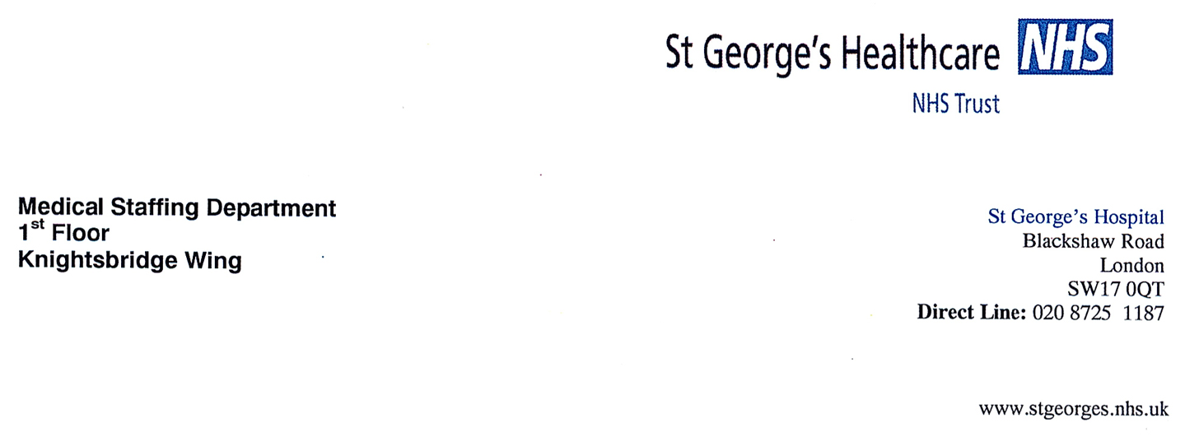

LEONARDO DA VINCI LETTER OF INTENT for

“Resident Mobility Programme” 2013 - 2016

Within the limits and constraints of contracts to be awarded under the LEONARDO DA VINCI Programme and the possibilities of partners, we hereby confirm our intention to collaborate in transnational placements of new graduates with the aim of enhancing their practical and communication skills, thereby contributing to the better quality of European health care. We plan to recieve postgraduate/specialist students/trainees for training from the Hungarian partner universities of the project.

We shall perform our activities with respect to the Quality Commitment of the Programme.

Partner data:
Organization / department  (original name) | Department of Cardiology  St George's Hospital, London
Organization / department  (English name) | As above
Legal representative | Paulie Puri
Function | Medical HR Office
Size of institution (number of employees) | 1000 beds
Contact Person | Pitt Lim
Function | Consultant Cardiologist
Address | Blackshaw Road, SW17 0QT
Country | United Kingdom
Telephone | +44 20 8725 1220
Fax | +44 20 8725 3178
E-Mail | Pitt.Lim@stgeorges.nhs.uk
Internet Site | -

Date: ............................ Signature of legal representative:..................................................

